Task 1
Model used: facebook/bart-large-mnli
Results of zero shot classification:
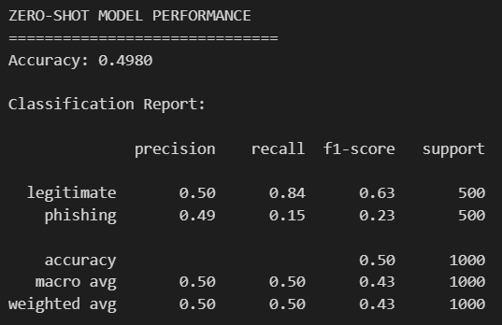
Confusion Matrix:
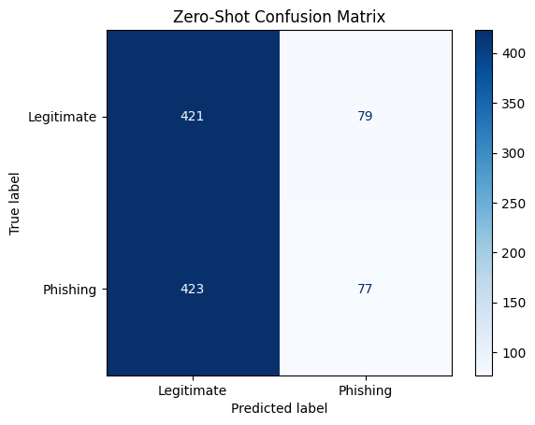

Task 2
Model used: facebook/bart-large-mnli
Results of finetuned models:
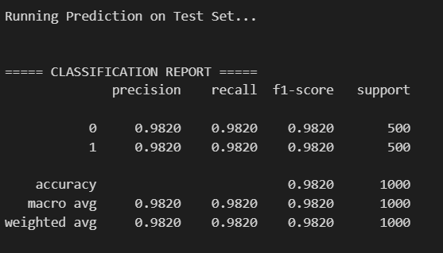
Confusion Matrix:
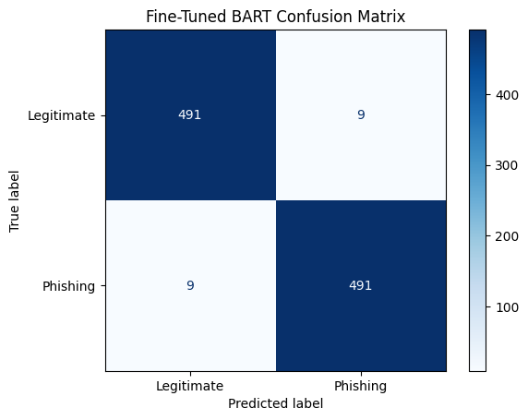

Task 3
Model used: distilbert-base-uncased
Results of finetuned models on dataset (from hugging face):
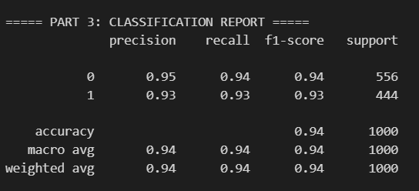
Confusion Matrix:
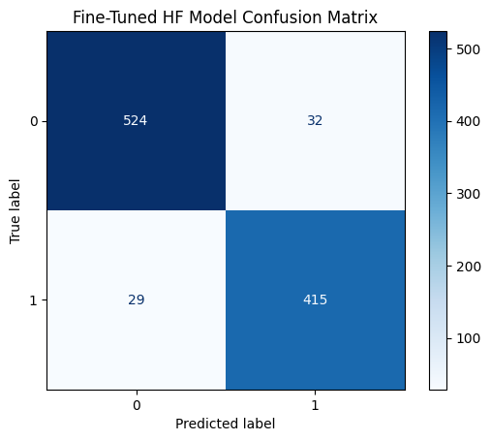

Task 4
Comparison of Metrics
- Accuracy
- Precision
- Recall
- F1-score
Task | Model | Accuracy | Precision | Recall | F1-score
1 | facebook/bart-large-mnli | 0.50 | 0.50 | 0.50 | 0.43
2 | facebook/bart-large-mnli | 0.98 | 0.98 | 0.98 | 0.98
3 | distilbert-base-uncased | 0.94 | 0.94 | 0.94 | 0.94

1. Performance Comparison: Which Model is Best?
The Winner: Facebook/BART-Large-MNLI (Fine-Tuned) The fine-tuned BART-Large model (Task 2) is the clear winner in terms of raw performance, achieving the highest scores across all metrics:
- Accuracy: 98%
- Precision & Recall: 98%
- F1-Score: 98%
Why did it perform better?
- Domain Specialization (vs. Zero-Shot): The most significant difference is between Task 1 (Zero-Shot) and Task 2 (Fine-Tuned). The Zero-Shot model achieved only 0.50 accuracy, which is equivalent to random guessing on a balanced dataset. This indicates that without specific training, the pre-trained model did not understand the subtle linguistic nuances of "phishing" versus "legitimate" emails in this specific dataset. Fine-tuning allowed the model to update its weights specifically for this binary classification task, leading to a massive jump in performance.
- Model Complexity (vs. DistilBERT): When comparing the two fine-tuned models, BART-Large outperformed DistilBERT (98% vs. 94%). BART-Large is a significantly larger model with more parameters and a more complex architecture than DistilBERT (which is a "distilled," smaller version of BERT). This higher capacity allows BART to capture more intricate patterns and dependencies in the text, resulting in slightly better prediction power.

2. Conclusion: Trade-offs and Potential Use Cases
While the Fine-Tuned BART model is the most accurate, the "best" model depends on the specific constraints of the deployment environment. Here is a breakdown of the trade-offs:
A. Analysis of Factors
- Accuracy:
  - Winner: Fine-Tuned BART (0.98).
  - Loser: Zero-Shot BART (0.50).
  - Trade-off: If the cost of a missed phishing email (False Negative) is catastrophic (e.g., in banking or government systems), the extra accuracy of BART is necessary. If a slight margin of error is acceptable, DistilBERT's 0.94 is very respectable.
- Computational Cost (Inference Speed):
  - Winner: Fine-Tuned DistilBERT.
  - Trade-off: BART-Large is a heavy model. Running inference on it requires significant GPU memory and time. DistilBERT is designed to be 40% smaller and 60% faster than standard BERT models. For a high-traffic email server processing millions of emails a day, DistilBERT would offer substantial cost savings and lower latency, even with a 4% drop in accuracy.
- Real-Time Adaptation:
  - Winner: Zero-Shot (Theoretically).
  - Trade-off: Zero-shot learning allows you to classify new categories (e.g., "Ransomware" vs. "Spam") instantly without retraining. However, as seen in the data (0.43 F1-score), its reliability is currently too low for production use in this domain. The Fine-Tuned models require a full retraining cycle to adapt to new types of attacks, which makes them slower to adapt but much more reliable.
B. Recommended Use Cases
- High-Security Enterprise (Fine-Tuned BART):
  - Scenario: Protecting the internal network of a financial institution.
  - Reasoning: The priority is security. The cost of a breach is millions of dollars, so the computational cost of running a heavier model like BART is justified to get that 98% accuracy.
- Mobile Apps or High-Volume Filters (Fine-Tuned DistilBERT):
  - Scenario: A lightweight email client on a smartphone or a free webmail provider processing billions of emails.
  - Reasoning: 94% accuracy is excellent for a general filter. The lower latency and CPU/GPU requirements of DistilBERT make it feasible to run at scale or on edge devices where BART would be too slow.
- Data Labeling Assistant (Zero-Shot):
  - Scenario: You have a new dataset and want to roughly categorize it before human review.
  - Reasoning: While not good enough for final detection, Zero-Shot could be used to "pre-label" data to help human annotators work faster, provided the prompts are engineered to get better than random results.

